***Test – 3 || 19 Dec 2024***

Arjun Patel – FRN13J1124/006

Q1Print even and Odd numbers in given range.

*#include*<stdio.h>

/*

Start = 10, end = 25

Odd 🡪 11 13 15 17 19 21 23 25

*/

int main(){

    int start, end;

    printf("Enter Start value\n");

    scanf("%d", *&*start);

    printf("Enter End value\n");

    scanf("%d", *&*end);

    printf("-----Even Numbers-----\n");

*for* (int i *=* start; i *<=* end; i*++*)

    {

*!*(i*%*2) *&&* printf("%d ", i);

    }

    printf("\n-----Odd Numbers-----\n");

*for* (int i *=* start; i *<=* end; i*++*)

    {

        i*%*2 *&&* printf("%d ", i);

    }

*return* 0;

}

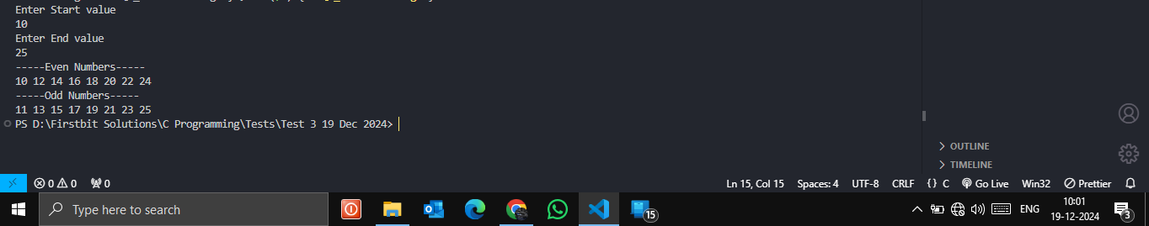

**(P. T. O)**

Q2)Add alternate num in sum in given range

*#include*<stdio.h>

int main(){

    int start, end;

    printf("Enter Start value\n");

    scanf("%d", *&*start);

    printf("Enter End value\n");

    scanf("%d", *&*end);

    int sum *=* 0;

*for* (int i *=* start; i *<=* end; i *=* i*+*2)

    {

        sum *+=* i;

    }

    printf("Sum is %d\n", sum);

*return* 0;

}

